



Effective 09-12-10

Attorney, you should provide written notice of the revocation to your prior agent(s) and to any

third parties who may have acted upon it, including the financial institutions where your accounts are located.

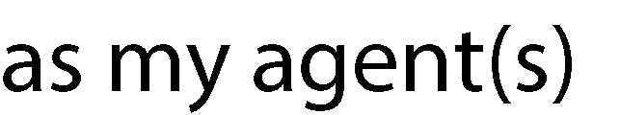



Effective 09-12-10

You may provide for specific succession rules in this section. provisions here:

Insert specific succession

**(e) This POWER OF ATTORNEY**

does not revoke any Powers of Attorney previously executed

If you do not intend to revoke your prior Powers of Attorney, and if you have granted the same authority in this Power of Attorney as you granted to another agent in a prior Power of Attorney, each agent can act separately unless indicated under "Modifications" that the agents with the same authority are to act together.



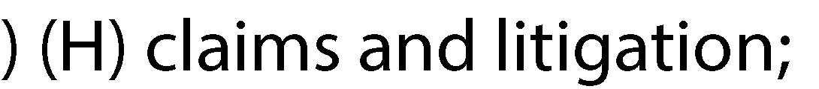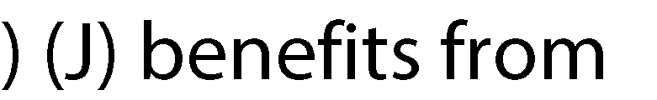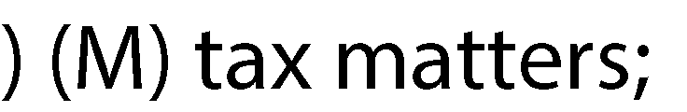

Effective 09-12-10

) (I) personal and family maintenance. If you grant your agent this authority, it will allow the

agent to make gifts that you have customarily have made to individuals, including the agent, and charitable organizations. The total amount of all such gifts in any one calendar year cannot exceed five hundred dollars;

use this Modifications section to grant your agent authority to make gifts or changes to interests in your property. If you wish to grant your agent such authority, you MUST complete

the Statutory Gifts Rider.

**(h) CERTAIN GIFT TRANSACTIONS: STATUTORY GIFTS RIDER:**

In order to authorize your agent to make gifts in excess of an annual total of $500 for all gifts described in (I) of the grant of authority section of this document (under personal and family maintenance), you must initial the statement below and execute a Statutory Gifts Rider at the same time as this instrument. Initialing the statement below by itself does not authorize your agent to make gifts. The preparation of the Statutory Gifts Rider should be supervised by a lawyer.

) (SGR) I grant my agent authority to make gifts in accordance with the terms and conditions of the Statutory Gifts Rider that supplements this statutory Power of Attorney.

N.Y. Statutory Short Form Power of Attorney

Effective 09-12-10

**(i) DESIGNATION OF MONITOR(S): (OPTIONAL)**

If you wish to appoint monitor(s), initial and fill in the section below:

(

) I wish to designate ,whose address(es)

is (are)

as monitor(s). Upon the request of the monitor(s), my agent(s) must provide the monitor(s) with a copy of the power of attorney and a record of all transactions done or made on my behalf.

Third parties holding records of such transactions shall provide the records to the monitor(s)

upon request.

**U) COMPENSATION OF AGENT(S): (OPTIONAL)**

Your agent is entitled to be reimbursed from your assets for reasonable expenses incurred on your behalf. If you ALSO wish your agent(s) to be compensated from your assets for services rendered on your behalf, initial the statement below. If you wish to define "reasonable compensation", you may do so above, under "Modifications."

) My agent(s) shall be entitled to reasonable compensation for services rendered.

**(k) ACCEPTANCE BY THIRD PARTIES:**

I agree to indemnify the third party for any claims

that may arise against the third party because of reliance on this Power of Attorney. I understand that any termination of this Power of Attorney, whether the result of my revocation of the Power of Attorney or otherwise, is not effective as to a third party until the third party has actual notice or knowledge of the termination.

**(I) TERMINATION:** This Power of Attorney continues until I revoke it or it is terminated by my death or other event described in section 5-1511 of the General Obligations Law. Section 5-

1511 of the General Obligations Law describes the manner in which you may revoke your Power of Attorney, and the events which terminate the Power of

Attorney.

**(m) SIGNATURE AND ACKNOWLEDGMENT:**

In Witness Whereof I have hereunto signed my nameon---- 20

PRINCIPAL signs here: _

State of-------

County of ss.:

On the day of i the year

before me, the undersigned, personally

appeared ,personally known to me or proved to me on the basis of satisfactory evidence to be the individual(s) whose name(s) is (are) subscribed to the within instrument and acknowledged to me that he/she/they executed the same in his/her/their capacity(ies), and that by his/her their signature(s) on the instrument, the individual(s), or the person upon behalf of which the individual(s) acted, executed the instrument.

Signature and Office of individual taking acknowledgment



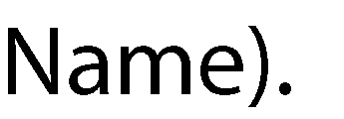

Effective 09-12-10

You may not use the principal’s assets to benefit yourself or any anyone else or make gifts to yourself or anyone else unless the principal has specifically granted you that authority in this document, which is either a Statutory Gifts Rider attached to a Short Form Power of Attorney or a non-statutory Power of Attorney. If you have that authority, you must act according to any instructions of the principal or, where there are no such instructions, in the principal’s best interest. You may resign by giving written

notice to the principal and to any co-agent, successor agent, monitor if one has been named in this document,





Effective 09-12-10

State of _New York

**(p) SUCCESSOR AGENT'S SIGNATURE AND ACKNOWLEDGEMENT OF APPOINTMENT:**

It is not required that the principal and the successor agent(s), if any, sign at the same time, nor that multiple successor agents sign at the same time. Furthermore, successor agents cannot use this

Power of Attorney unless the agent(s) designated above is/are unable or unwilling to serve.

State of _New York





Effective 09-12-10

State of _New York

RETURN BY MAIL TO:

**N.Y. Statutory Short Form Power of Attorney**

**N.Y. Statutory Gifts Rider Effective 9/12/2010**

**Affidavit Power of Attorney**

**STATE OF ) COUNTY OF ) ss:**

**, being duly sworn, deposes and says as follows:**

**1. This affidavit is made in connection with the (transfer)(mortgage) of property known as**

**, in , New York to**

**.**

**2. I am (the)(an) agent named in the Power of Attorney (hereafter "Power of Attorney") made by , as principal (the "Principal"), dated .**

**3. I do not have actual notice that the Power of Attorney has been modified in any way that would affect my ability to authorize or engage in the present transaction for which the Power of Attorney is being used, or notice of any facts indicating that the Power of Attorney has been so modified.**

**4. I do not have actual notice of the termination or revocation of the Power of Attorney, or notice of any facts indicating that the Power of Attorney has been terminated or revoked, and the Power of Attorney remains in full force and effect.**

**5. If the Principal has been my spouse, we are not divorced and our marriage has not been annulled.**

**6. If I am a successor agent, the prior agent is no longer able or willing to serve.**

**Sworn to before me this day of , 20 .**

**Notary Public**

**NOTE: If multiple agents are appointed, an affidavit is to be executed by each agent.**